STANDING ORDER FORM
To make a regular donation to Stroud Court Community Trust, please provide the following details and return this form to us at the address below

First name Surname
Address

Telephone Email
Standing Order Instructions
To the Manager of: ………………………………………………………………………………………. Bank
Branch Address: ……………………………………………………………………………………….
………………………………………………………………………………………. Post Code: …………….

Please debit my Bank Account
Account Number: …………………………………………………………. Sort Code:
Name of Account: …………………………………………………………. The sum of £……………… (figures)
Amount in words: …………………………………………………………..
Every (state frequency: ………………………………………………………….. Date of first payment: ...……/.…..…/………..
For the credit of Stroud Court Community Trust, please pay to: Lloyds TSB Bank plc, Rowcroft, Stroud,
Glos GL5 3BD Sort Code 30-98-29 Account 00953082

Today’s date: ………………………………. Signed: ……………………………………………………………

Gift Aid: Please treat my donation as Gift Aid donation and claim back an additional 28p on every
£1 that I give. I confirm I am a UK tax payer

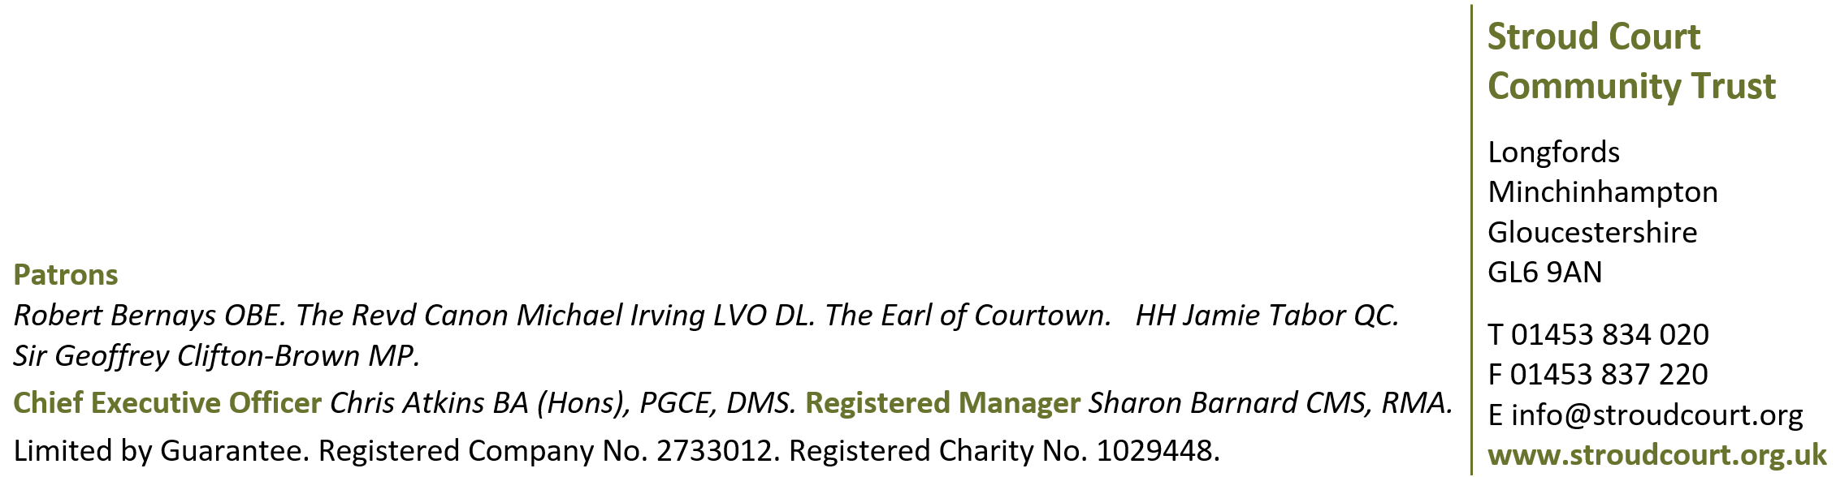
Please contact us using the details below if you have any queries. Thank you for your support.

