CODICIL FORM
Please update my Will with a Codicil
I have already made my Will, but I would like to benefit the work of Stroud Court Community Trust on my death.
Please complete the details below in block capitals and pass the form to your solicitor.

To (Solicitors):
Address:
I have already made a Will dated: ………………………………………….
I have previously made no/one/two/more Codicils to my Will (delete as appropriate)
I would like to make a Codicil, adding the following gift for Stroud Court Community Trust: I give to Stroud Court Community Trust, Longfords, Minchinhampton, Glos. GL6 9AN Registered Charity Number 1029448 (please select one of the following options)
Cash Gift The sum of £ ………………………………… OR
Gift of Specific Assets My …………………………………………………………… (e.g. property, car, shares) OR
Residual Gift A ……% share of my residual Estate to be used for the general purposes of the Charity
Please contact me to discuss this Codicil and your expected fees. My contact details are:
Name:
Address:
Telephone:
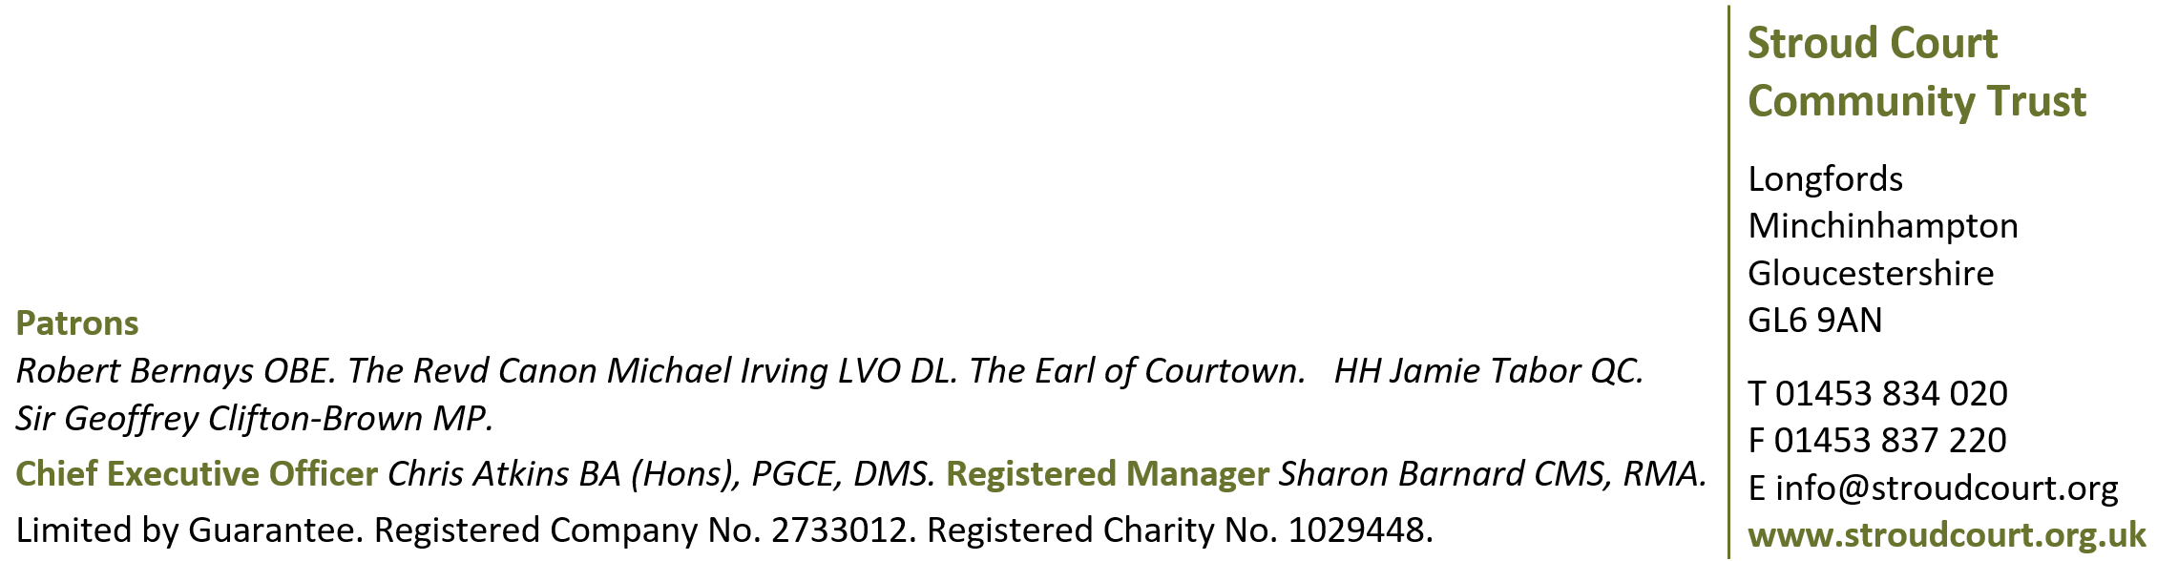
It is important you contact your solicitor to discuss whether a Codicil is the best option for you – particularly if you wish to make other changes to your Will at the same time.

